# RandPwGen Service

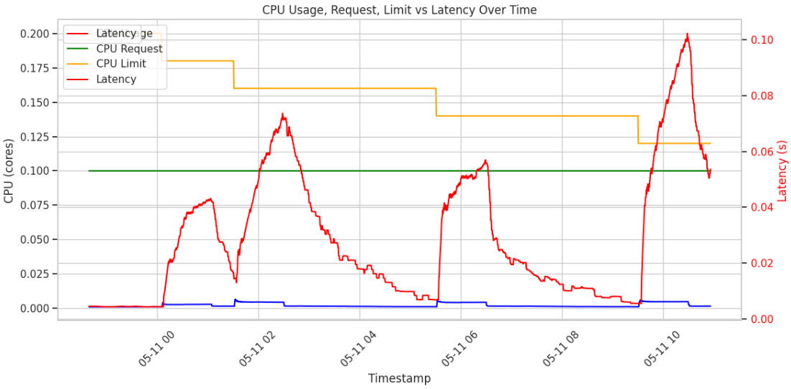

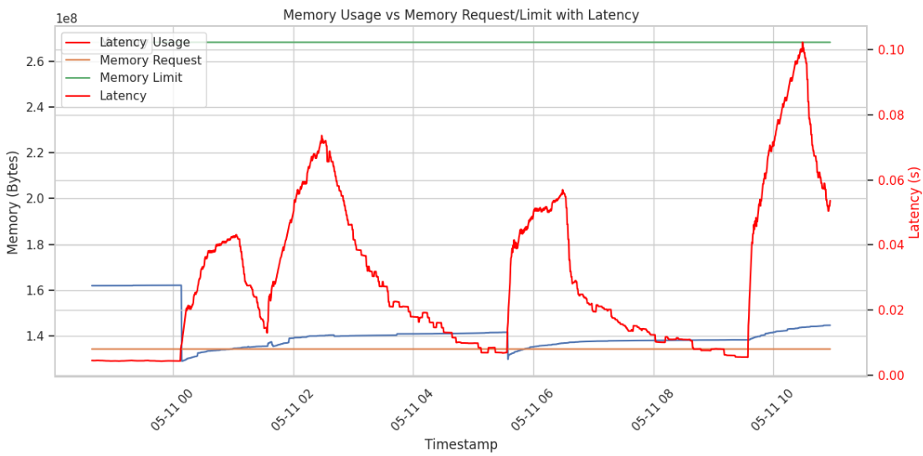

* CPU usage (blue) rises gradually, peaks, then falls.
* Latency (red) follows a smoother, less spiky curve compared to the hash generator.
* Unlike hash generation, latency here increases proportionally with load, not abruptly.
* This indicates the password generator is likely less CPU-intensive per request and can handle small bursts without immediately saturating CPU. Latency degradation is more graceful, suggesting:
* Lightweight password generation logic (random sampling)
* Efficient concurrency (e.g., async)
* No blocking computation (unlike hashing)
* No correlation between memory and latency (unlike the hash generator).
* Latency is **purely CPU-bound** here, not memory-bound. You’re not dealing with:
* GC pressure
* Fragmentation
* Memory-related queuing
* Like the hash generator, latency drops fast after CPU usage declines.
* Indicates:
  + No queued backlog
  + Stateless request handling
  + Possibly short-lived connections

Why spike at 05-11 06 is lower than the previous ones?

1. Load Have Been Slightly Lower

* Memory usage at 05-11 06 peaks lower than at earlier timestamps.
* Implies that the incoming request rate was possibly slightly reduced, or the load was less bursty.
* Less burst = fewer concurrent requests to queue or throttle -> latency spike was dampened.

1. CPU Usage Decay Was Smoother

* After peaking, CPU usage drops more gradually, suggesting fewer queued requests or a more stable serving pattern.
* This smoother behavior avoids congestion collapse, helping latency remain manageable.

Why memory usage increased in this service?

Workload Nature: CPU-Bound vs Memory-Bound

* Hash generation (SHA) is often CPU-bound but also involve:
  + Temporary large objects (hash buffers, salts, input copies).
* If CPU is throttled:
  + Requests start queuing up (because they take longer).
  + These pending requests hold onto memory (e.g., input buffers, request objects).
  + Memory usage increases over time.

Why memory usage drops when CPU limits drop?

1. Reduced CPU -> Less Work Done -> Less Memory Needed

When we reduce CPU limits:

* Our application gets less CPU time.
* It processes fewer requests per unit time.
* Fewer requests = fewer in-flight objects, smaller queues, and less transient memory allocation.

1. Garbage Collection (GC) Kicks In More Aggressively

* With lower CPU, the app slows down, which may delay object creation.
* Some runtimes (Java) have background GC which now gets more breathing room (since fewer user threads are active).
* That leads to more frequent memory cleanup, resulting in visible drops in memory usage.

1. Latency Increases = Request Backoff or Drop

* In real systems (with scaling), high latency can lead to:
  + Clients backing off.
  + Requests being dropped or rejected.
  + Work being deferred.
* This results in less memory pressure, because fewer request contexts are active.